BE-7 NUCLEI PRODUCED BY GALACTIC COSMIC RAYS AND SOLAR ENERGETIC PARTICLES IN THE EARTH’S ATMOSPHERE

M. Yoshimori¹, H. Hirayama¹, S. Mori¹, K. Sasaki¹ and H. Sakurai²

¹School of Science, Rikkyo University, 3-34-1 Nishi-Ikebukuro, Toshima-ku, Tokyo,171-8501, Japan
- ²School of Science, Yamagata University, 1-4-12 Kosirakawa, Yamagata,990-8560, Japan

ABSTRACT

Be-7 radioactive nuclei with a half-life of 53.3 days result from spallation reactions of galactic cosmic rays (GCR) and solar energetic particles (SEP) with N and O nuclei in the Earth’s atmosphere. We calculate the average global production of Be-7 in the atmosphere by GCR and SEP. The result indicates that an intense SEP event produces a large amount of Be-7 in the polar stratosphere and part of them could be transported to the surface at lower latitudes. The ground-level measurement of Be-7 in Japan exhibits the possibility of enhancement in the Be-7 radioactivity associated with the intense SEP event on July 14, 2000. In addition, the present experiment shows seasonal variations in the surface Be-7 concentration which peaks in spring and autumn. We discuss the possible air mass mixing between the stratosphere and troposphere to explain the measured seasonal variations. The surface concentration of Pb-210 nuclei indicates a similar trend to that of Be-7 and we suggest two possible explanations.

INTRODUCTION

Galactic cosmic rays (GCR) and solar energetic particles (SEP) interact with Earth’s atmospheric nuclei and produce many different isotopes through nuclear interactions. In particular, Be-7 is a short-lived radioisotope (half-life is 53.3 days) which results from spallation reactions of energetic protons with atmospheric N and O nuclei. The Be-7 production rate has been calculated by several authors in the past (Masarik and Beer, 1999; Nagai et al., 2000). The Be-7 emits a gamma-ray line at 478 keV from the electron-capture process of ⁷Be + e⁻ → ⁷Li + ν. The Be-7 production rate depends on the 11-year cycle of solar activity because there is an anti-correlation between the GCR flux and the solar activity. The difference in the Be-7 production between the sunspot minimum and maximum is 70 % in the polar region above 14 km in altitude and 7 % in the lower equatorial atmosphere. The SEP flux above 10 MeV is strongly enhanced (more than 10⁴ times the GCR flux) when an extraordinary large SEP event takes place in the solar maximum. In fact, the NASA LDEF experiment showed a strong correlation between the Be-7 activity and the solar proton events (Phillips et al., 2001).
On the other hand, the study of Be-7 in the atmosphere provides important information on atmospheric transport processes. The source distribution of GCR-produced Be-7 peaks around 20 km in altitude and decreases exponentially with altitude. A produced Be-7 nucleus rapidly attaches to aerosol particles in the upper atmosphere and scavenging by precipitation is the main process bringing Be-7 to the Earth’s surface. A ground-level measurement of Be-7 radioactivity provides a clue on the air mass mixing between stratosphere and troposphere and a subsequent transport in the Earth’s atmosphere.
In this paper we calculate the global production of Be-7 from GCR and SEP and report the ground-level measurements of Be-7 radioactivity in Yamagata and Tokyo. The temporal variation of the Be-7 radioactivity on the surface is discussed in terms of the Be-7 production process and atmospheric motion
Be-7 PRODUCTION IN THE EARTH’S ATMOSPHERE

Radioactive Be-7 results from nuclear reactions of GCR and SEP with atmospheric N and O nuclei. GCR produce Be-7 at nearly constant rate, while SEP produce Be-7 in association with an intense solar proton event. The frequency of intense solar proton events is less than a few events in a year. The revised cross sections for Be-7 production from p-N and p-O spallation reactions (Bodemann et al., 1993) are used. The cross section for p-N reaction peaks at 20 MeV and is almost constant above 40 MeV. The GCR proton spectrum was approximated by Castagnoli and Lal (1980) as a function of solar activity. The proton flux is anticorrelated with the solar activity. We calculate the global average Be-7 production rates by GCR and SEP in the solar maximum.
GCR incident on the top of the atmosphere consists mainly of protons with energies around 1 GeV. The characteristic feature of nuclear interactions at these energies is the development of this cascade process. On the basis of these features of particle cascade development, one expects that the production rate begins to increase at the top of the atmosphere, reaches a maximum at a depth between 100-200 gcm⁻² depending on nuclide and latitudes, and finally decreasing gradually down to the Earth’s surface. The depth dependence of the proton and neutron fluxes in the Earth’s atmosphere was calculated by Masarik and Beer (1999). The neutron flux is larger by almost two orders of magnitude and reaches its maximum in the depth interval 75-125 g cm⁻². At atmospheric depths exceeding 180 g cm⁻², the total flux shows an exponential decrease with energies an effective attenuation length between 150-170 gcm⁻². The calculation indicates that the secondary neutrons with energies above 20 MeV much contribute to production of Be-7 in the stratosphere.
SEP consists of 98 % protons and 2 % heavier nuclei. The energies are typically in the range of 1-100 MeV. Because of their relatively low energies, they can cause nuclear interactions in the Earth’s atmosphere only high geomagnetic latitudes above 60 degree, and even there the nuclide production is restricted to the very top of the atmosphere. The long-term average production of cosmogenic nuclei by SEP is not expected to be significant. Some huge SEP events produce proton fluxes much higher than the average observable in some layer in polar ice (Masarik and Reedy, 1995).
The global Be-7 production rate in the Earth’s atmosphere depends on the number of atoms for target nuclei, the energy-dependent cross section for the production of Be-7 and the total flux of Be-7 producing particles as a function of geomagnetic latitude and atmospheric depth. The average GCR and intense SEP proton (2000 July 14 event) spectra are shown in Fig. 1. The energy spectrum of SEP protons is so steep that low-energy protons (less than a few tens of MeV) are dominant. Arrival of most SEP protons is essentially confined to the polar region except for rare intense and energetic events, e.g. ground level event.

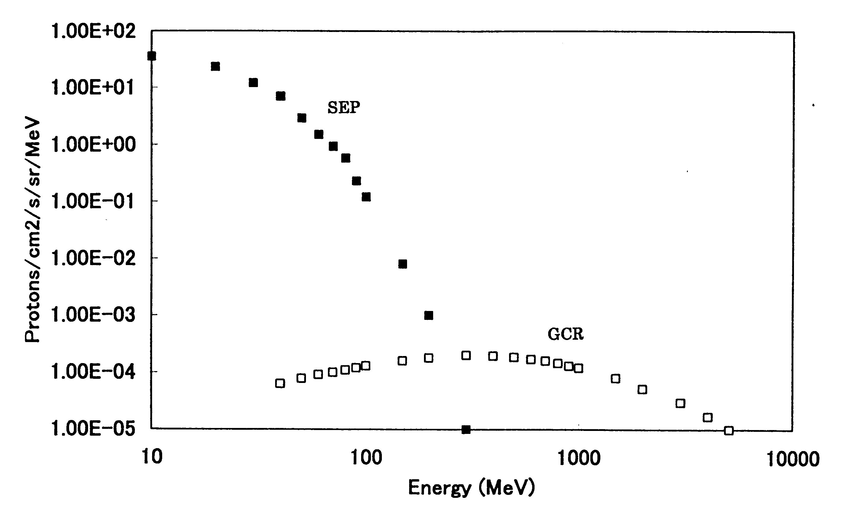
Fig. 1 GCR and SEP proton energy spectra

In a case of the SEP event on July 14, 2000, the time-integrated proton flux (fluence) over the event duration is ~10¹⁰ protons cm⁻² above ~10 MeV. It is about 10⁴ times the GCR proton fluence. Hence, just after an intense SEP event takes place, an extraordinarily high flux of low-energy SEP protons reach the vicinity of the geomagnetic poles. Since the threshold energy of Be-7 production is ~20 MeV, most Be-7 are generated in a thin layer of the polar atmosphere (the effective thickness corresponds to a range of 20–30 MeV protons of ~1 g cm⁻²). The global Be-7 production rates from GCR and SEP are estimated to be ~ 0.02 and ~ 0.6 cm⁻² s⁻¹, respectively. The derived SEP/GCR production ratio is about 30. The observed Be-7 radioactivity above 320 km in association with the most intense SEP event on October, 1989 is about 100 times the GCR production rate (Phillips et al., 2001) based on the calculations of Masarik and Reedy (1995).
A steady state of the Be-7 concentration in the atmosphere is reached as a result of a balance between production, loss, decay and global dispersion in the stratosphere and troposphere. The transportation of Be-7 is a complicated process and discussed by Rehfeld and Heimann (1995). Whether SEP-produced Be-7 nuclei are detected on the surface depends on the time scale of the Be-7 transport from stratosphere to ground. If the transport time is much longer than the half-life of Be-7 (53.3 days), it is difficult to detect the enhancement of the surface Be-7 radioactivity.

GROUND-LEVEL MEASUREMENT OF BE-7

We have started the ground-level measurements of the Be-7 radioactivity using a high-volume air sampler. We have measured a daily dry deposition of Be-7 in Yamagata, Japan since January, 2000 and a weekly dry deposition in Tokyo since January, 2002. The high-volume air sampler has a collecting power of 16.7 l/s. The dry deposition samples are counted with a Ge gamma-ray spectrometer which consists of a high-purity coaxial Ge detector surrounded with a 10 cm-thick lead shield. The effective volume of the detector is 90 cm³ and the photopeak efficiency is 5 % at 478 keV. The energy resolution is 1.60 keV (FWHM) at 478 keV. Pulse height spectrum analysis is made with a computer-based multi-channel analyzer (4096 energy channels). A typical gamma-ray spectrum of the sample is shown in Fig. 2. We see the strongest Be-7 line at 478 keV. The other lines at 46.5, 511 and 1461 keV result from Pb-210, positron annihilation and K-40, respectively. We determine Be-7 radioactivities taking account the decay of Be-7.

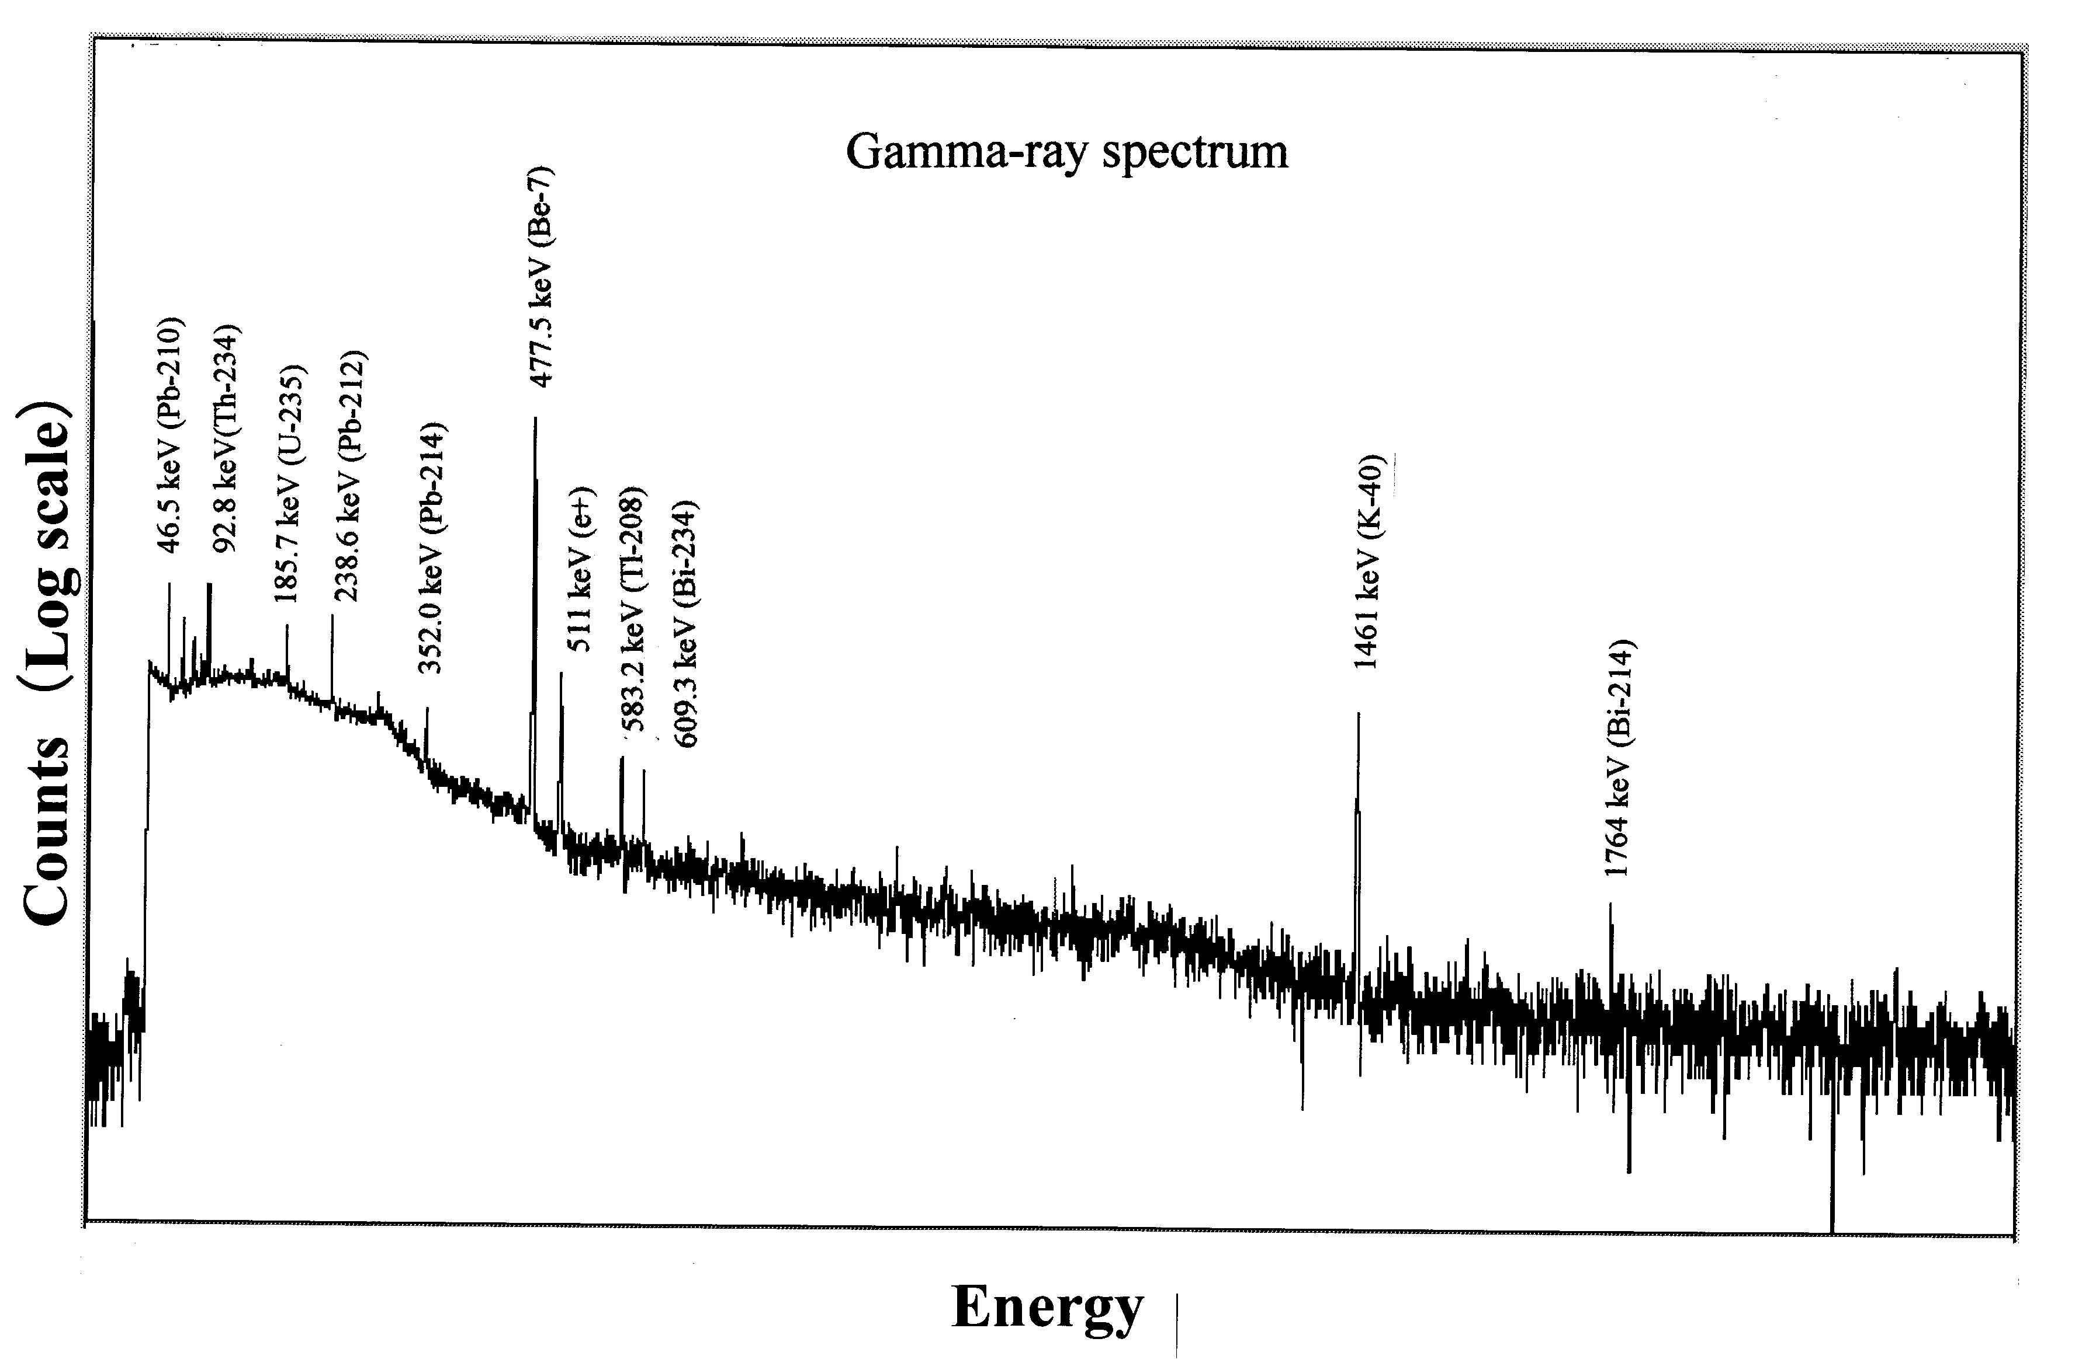

Fig. 2 Gamma-ray spectrum of the sample measured on the surface

First we show the time variations in the monthly surface air concentration of Be-7 in 2000 in Fig. 3. A large SEP event occurred on July 14 (X5.7 flare), 2000. The GEOS data showed that the proton flux increased more than 10⁴ times in three energy bands of >10, >50 and > 100 MeV (http://www.sec.noaa.gov). Fig. 3 shows an enhancement in the surface Be-7 radioactivity in October–November. There is the possibility that this enhancement could be due to the large July 14 SEP event. However, it may result from the air mass transport in the upper atmosphere.
Next we show the time variations in the weekly dry deposit of Be-7 in 2002 in Fig. 4. Although there was no large SEP event in 2002, the measurement indicates definite temporal variations in the Be-7 radioactivity. The Be-7 radioactivity peaks in spring (March–April) and autumn (September-October). We believe that the spring and autumn peaks could be caused by a seasonal variation of atmospheric air mass exchange between the stratosphere and troposphere, as discussed later.

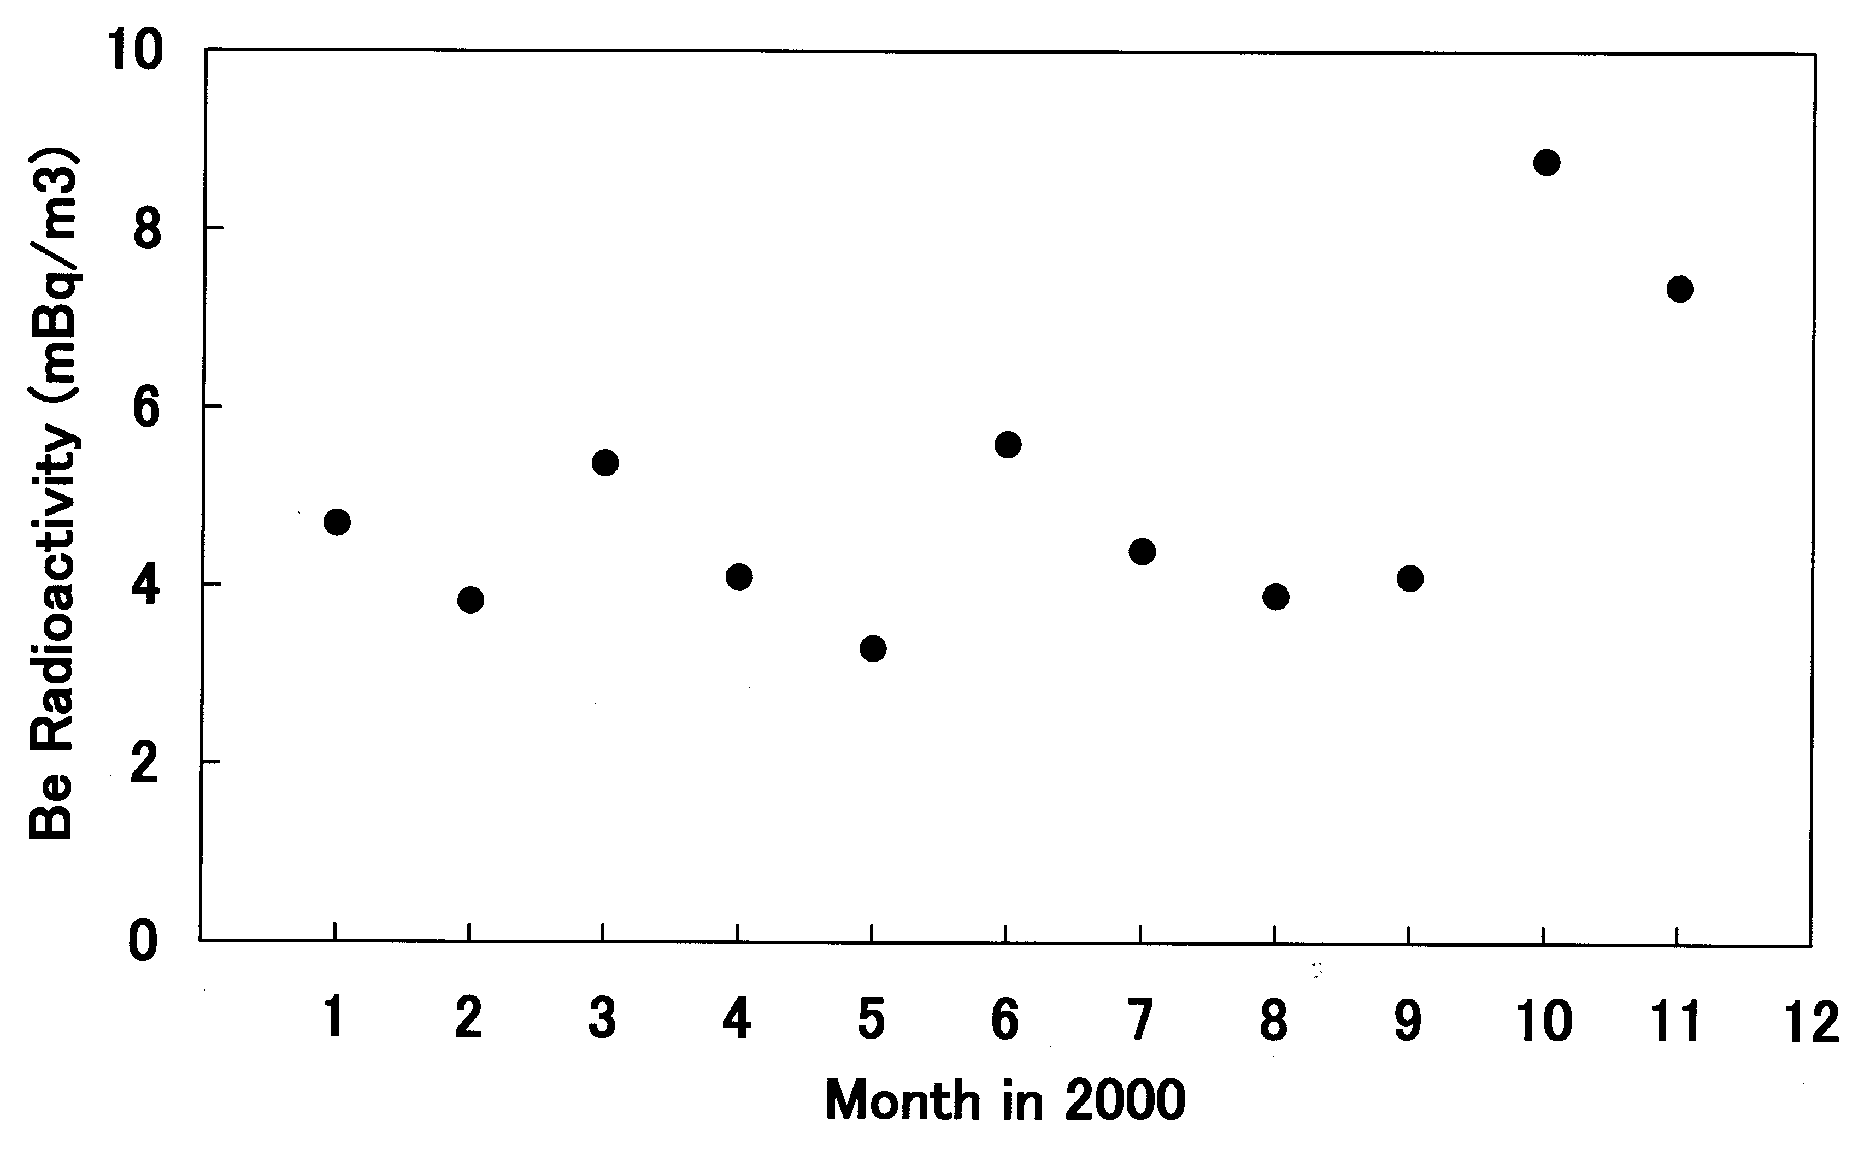

Fig. 3 Time variations in the Be-7 concentration on the surface in 2000.

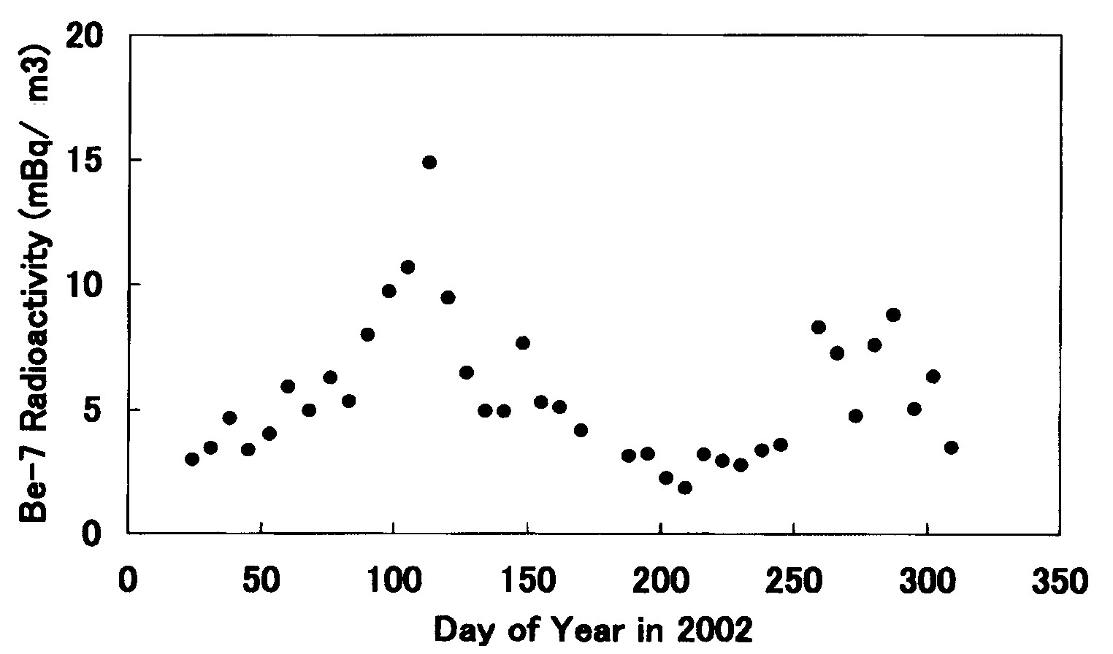

Fig. 4 Time variations in Be-7 concentration on the surface in 2002

DISCUSSION

The monthly average surface air concentration of Be-7 shown in Fig. 3 shows an enhancement in October-November. A large number of protons reached the polar region of the Earth in association with the July 14 event and the Be-7 concentration should become extraordinarily high in the polar upper atmosphere. The polar Be-7 could not only be transported downward but also to low latitudes. Part of the Be-7 transported to low latitudes could fall to the surface. Hence, there is the possibility that the enhancement of Be-7 concentration in October-November could be related to the SEP event. However, the time scale of the transport of the Be-7 from the polar stratosphere to the surface of midlatitude has not well been understood. Probably it depends on the season and location. Another possible explanation of the enhancement in October-November is air mass mixing between the stratosphere and troposphere, as discussed in a next paragraph.
Fig. 4 exhibits that the surface Be-7 concentration peaks in spring and autumn. Since the measured seasonal variations in the Be-7 radioactivity are independent on SEP events, we have to look for another possibility. A similar trend was indicated by Megumi et al. (2000) on the basis of Be-7 measurements in 1983-1997 in Osaka, Japan. Implications on air mass exchange between the stratosphere and troposphere (Reiter ,1975) were discussed from the distribution of Be-7 in the troposphere (Viezee and Singh, 1980). Dibb (1989) considered that strong mixing between the stratosphere and troposphere takes places in spring. Further, Dibb and Meeker (1994) proposed the increased vertical (downward) mixing in the upper troposphere. A stratospheric mean residence time was derived to be 21 months from a global three-dimensional transport model of the atmosphere (Rehfeld and Heimann, 1995). On the other hand, a mean tropospheric residence time is inferred to be 5-15 days from a global three-dimensional simulation of Pb-210 (Balkanski et al., 1993). Hence, the time scale of transport of Be-7 in the atmosphere is dominated by the stratosheric residence time. The mixing effect causes shortening of the residence time of Be-7 in the stratosphere, leading to the enhanced Be-7 radioactivity on the surface. The present measurement (Fig. 4) suggests that the residence time is reduced to be less than a few months. There is the possibility that the spring and autumn peaks could be explained from the air mass mixing process.
A few Be-7 measurements on the surface have been reported so far. We compare the present Be-7 result with previous ones. Dibb (1989) measured the Be-7 radiaoactivity on the surface in Maryland, USA in 1986-1987 and his result indicated 3.3-5.0 mBq/m³. Dibb and Meeker (1994) obtained 3.0±1.5 mBq/m³in Alert , Canada in 1990-1992. Megumi et al. (2000) reported the Be-7 radioactivity of 3-9 mBq/m³ in Japan in 1983-1997. The present Be-7 radioactivity on the surface is consistent with the previous ones within the experimental errors.
We simultaneously measured the Pb-210 (46 keV gamma-ray line is emitted) concentration on the surface with the same air sampler. The measured temporal variation in Pb-210 is shown in Fig. 5. It shows similar seasonal variations to those of Be-7. The Earth’s crust contains the radioactive isotope U-238 that decays into Ra-226 to Rn-222, which effuses out of the ground into the atmosphere. The Pb-210 is the daughter nucleus of Rn-222. Despite the different production-source terms for Be-7 and Pb-210, there exists a correlation between both temporal variations. The similar seasonal variations of Be-7 and Pb-210 were reported from investigations of the atmospheric fallouts of these two nucleides (Baskaran, 1995). The present measurements imply possibilities that (1) Part of Pb-210 nuclei also could move up to the stratosphere and precipitate to the troposphere when the strong air mass exchange takes place in spring and autumn or (2) the vertical transport of Be-7 (from the upper troposphere to the middle or lower troposphere) and Pb-210 (from the lower troposphere to upper troposphere) could occur due to decreased stability of the troposphere in spring and autumn. The temporal variations of the Be-7 and Pb-210 concentrations seem to depend on a location and we have not yet fully understand the correlation between these two nucleides.
The measurement of short-life Be-7 concentration on the surface plays an important role as a tracer for study of the air mass motion in the stratosphere and troposphere. We need long-term continuous measurements of Be-7 and Pb-210 to advance the understanding of the air mass transport processes in the upper atmosphere.

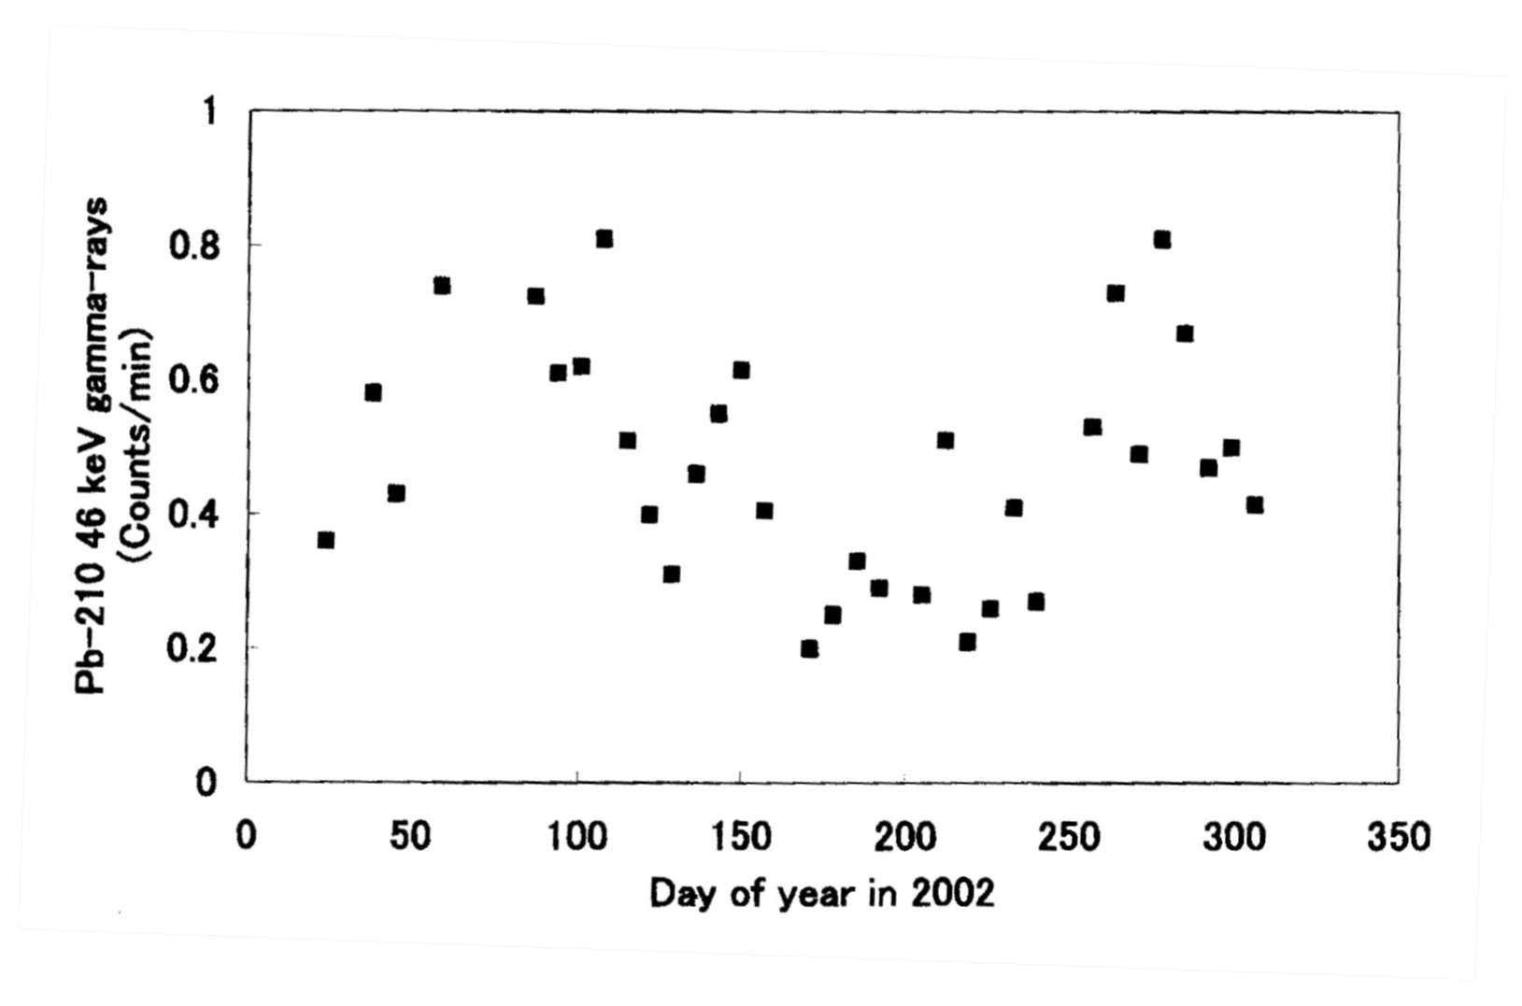
Fig. 5 Time variation in Pb- 210 on the surface in 2002.

REFERENCES

Baskaran, M., A search for the seasonal variability on the depositional fluxes of Be-7 and Pb-210, J.Geophys. Res. 100, 2833-2840, 1995.
Balkanski, Y. J. et al., Transport and residence times of tropospheric aerosols inferred from a global three-dimensional simulation of Pb-210, J. Geophys. Res.,98, 20573-20586, 1993.
Bodemann, R.H-J. et al., Production of residual nuclei by proton-induced reactions on C, N, Mg, Al, and Si, Nucl. Instr. Meth., B82, 9-31, 1993.
Castagnoli, G.C. and D. Lal, Solar modulation effects in terrestrial production of carbon14, Radiocarbon, 22, 133-158, 1980.
Dibb, J.E., 1989, Atmospheric deposition of Be-7 in the Chesapeake Bay region, J. Geophys. Res., 94, 2261-2265, 1989.
Dibb, J.E.and L.D. Meeker, Estimation of stratospheric input to the Arctic troposphere: Be-7 and Be-10 in aerosols at Alert, Canada, 1994, J. Geophys. Res. 99, 12855-12864, 1994.
Masarik, J. and J. Beer, Simulation of particle fluxes and cosmogenic nucleid production in the Earth’s atmosphere, J. Geophys. Res. 104, 12099-12111, 1999.
Masarik, J. and R.C. Reedy, Terrestrial cosmogenic-nucleid production systematic calculated from numerical simulations, Earth Planet. Sci. Lett. 136, 381, 1995.
Megume, K. et al., Factors, especially sunspot number, causing variations in surface air concentrations and depositions of Be-7 in Osaka, Japan, Geophys. Res. Lett. 27, 361, 2000.
Nagai, H, W. Tada and T. Kobayashi, Production rates of Be-7 in the atmosphere, Nucl. Instr. Method B172, 796, 2000.
Phillipes, G.W. et al., Correlation of upper-atmospheric Be-7 with solar energetic particle events, Geophys. Res. Lett., 28, 939-942, 2001.
Rehfeld, S and M. Heimann, Three-dimensional atmospheric transport simulation of the radioactive tracers Pb-210, Be-7, Be-10 and Sr-90, J. Geophys. Res., 100, 26141-26162, 1995.
Reiter, E.R., Stratospheric-tropospheric exchange processes, Rev. Geophys. Space Phys. 13, 459-474,
1975.
Viezee, W., and H.B. Singh, The distribution of Be-7 in the troposphere: Implications on stratospheric/tropospheric air exchange, Geophys. Res. Lett, 7, 805-808, 1980.

E-mail address of M. Yoshimori yosimori@rikkyo.ac.jp

