CORONAL MASS EJECTION INTERACTION AND PARTICLE ACCELERATION DURING THE 2001 APRIL 14-15 EVENTS

N. Gopalswamy¹, S. Yashiro², M. L. Kaiser¹, and R. A. Howard³

¹NASA Goddard Space Flight Center, Greenbelt, MD 20771, USA
²The Catholic University of America, Washington DC 20064, USA
³Naval Research Laboratory, Washington DC 20064, USA

ABSTRACT

Two successive solar energetic particle (SEP) events associated with fast and wide coronal mass ejections (CMEs) on 2001 April 14 and 15 are compared. The weak SEP event of April 14 associated with an 830 km/s CME and an M1.0 flare was the largest impulsive event of cycle 23. The April 15 event, the largest ground level event of cycle 23, was three orders of magnitude more intense than the April 14th event and was associated with a faster CME (1200 km/s) and an X14.4 flare. We compiled and compared all the activities (flares, CMEs, interplanetary conditions and radio bursts) associated with the two SEP events to understand the intensity difference between them. Different coronal and interplanetary environments of the two events (presence of preceding CME and seed particles ahead of the April 15 event) may explain the intensity difference.

INTRODUCTION

Solar energetic particle (SEP) events are of two types (see, e.g. Lin, 1987, Reames, 1999): “impulsive” (short-lived) events from flares and “gradual” (long-lived) events from shocks driven by coronal mass ejections (CMEs). Most of the CMEs associated with large SEP events are also associated with intense flares, so it is often difficult to untangle the contributions from flare and shock sources (Cliver, 1996). In addition, earlier events may influence the later events: flare particles from a sequence of preceding flares may be present in the inner heliosphere and get accelerated by CME-driven shocks (Mason et al., 1999). When CMEs occur in rapid succession from the same neighborhood, some of the SEPs produced by one CME may become seed particles to the next CME (Kahler, 2001). Presence of preceding CMEs means disturbed conditions in the coronal and IP medium through which later CMEs propagate: density, flow velocity, magnetic field strength, magnetic field geometry, and solar wind composition may be different compared to normal solar wind conditions (Gopalswamy et al., 2003). Large SEP events with preceding wide CMEs within a day from the same active region tend to have higher intensity (Gopalswamy et al., 2003). Propagation of CME-driven shocks through the coronal and IP medium disturbed by previous CMEs seems to be commonplace, especially for CMEs associated with large SEP events (Gopalswamy et al., 2002b). Although interactions among shocks and ejecta have been known for a long time from in situ observations (Burlaga et al., 1987), two-dimensional images from the Solar and Heliospheric Observatory (SOHO) have provided direct evidence for CME interactions very close to the Sun (Gopalswamy et al., 2001; 2002a). Strengthening of the shocks when propagating through the dense parts of preceding CMEs and trapping of particles in the closed loops of preceding CMEs were suggested as possible mechanisms that increase the efficiency of particle acceleration (Gopalswamy et al., 2002b). Recent numerical simulations support such shock strengthening (Odstrcil et al., 2003). There are also other simulation studies, which indicate shock weakening at large distances from the Sun (Vandas et al., 1997), probably because the magnetic field in the CME (magnetic cloud) might become the deciding factor rather than the density as invoked by Gopalswamy et al. (2001; 2002b). This can be seen from the fact that both density (n) and magnetic field (B) changes contribute to the change in local Alfven speed (Va): dVa/Va = dB/B - ½ dn/n. Particle trapping between converging shocks was proposed long ago for explaining ground level events (GLEs) such as the 1972 August 4 event (Pomerantz and Duggal, 1974; Levy et al., 1976). Kallenrode and Cliver (2001) considered configurations including shocks and CMEs that can enhance the SEP intensity significantly. Recently, Bieber et al. (2002) found evidence for energetic particle reflection from the enhanced magnetic field region behind a preceding shock. Thus, CME interaction can take place in a variety of ways at various distances away from the Sun, potentially influencing particle acceleration. In this paper, we compare the SEP events of 2001 April 14 and 15 that originated from the same active region (AR 9415) within 20 hrs of each other with enormous differences: the first event was an impulsive event with an intensity three orders of magnitude smaller than that of the second event. We discuss various possibilities including CME interaction that might account for the differences.

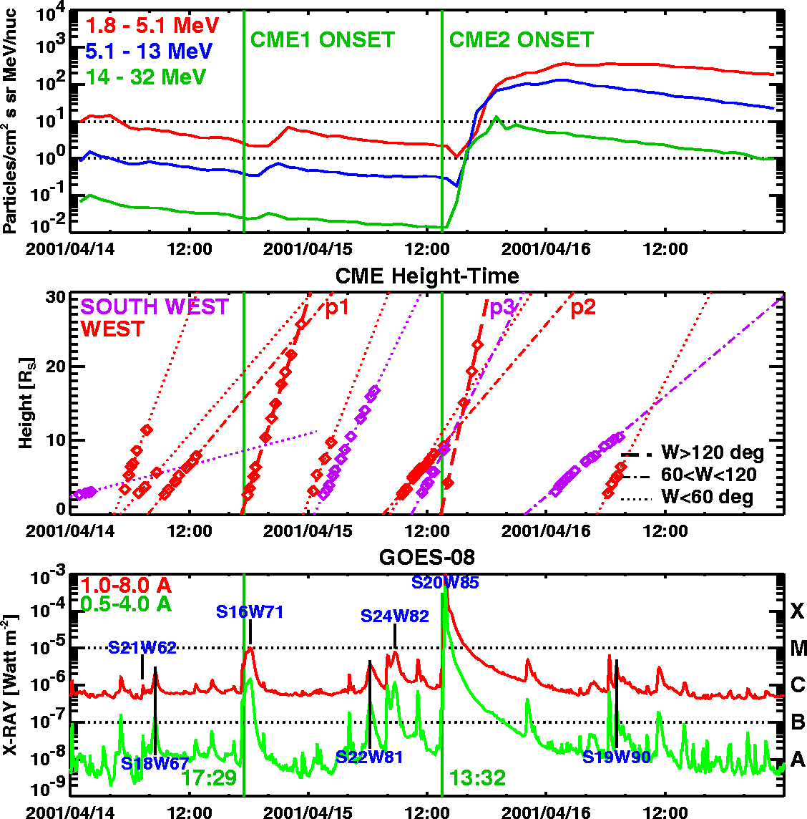

Fig. 1. The SEP events of 2001 April 14 and 15 as observed by SOHO/ERNE in three channels (top), the height-time plots of all the western hemispheric CMEs from April 14 to 17 (middle), and the GOES soft X-ray intensity in high and low energy channels with the heliographic coordinates of the associated flares marked (bottom). The vertical lines indicate the onset times of the associated CMEs. p1, p2 and p3 are wide CMEs from the western hemisphere, but not from the same AR as CME1 and CME2. p1 may be a combination of two narrow CMEs.

OBSERVATIONS

The two SEP events in question occurred on 2001 April 14 and 15 in association with eruptions separated by ~ 20 h from AR 9415. The April 14 event (SEP1) was the largest impulsive SEP event of the current solar cycle as of the present writing; the April 15 event (SEP2) was the largest ground level event (GLE) (see Tylka et al., 2002 for a detailed discussion on the spectral properties of the two events). Figure 1 shows the time profile of the proton intensity as obtained by SOHO’s Energetic and Relativistic Nuclei and Electron (ERNE) experiment (Torsti et al.,1995). The time profile in the ERNE 14-32 MeV channel was similar to the GOES >10 MeV channel. SEP2 started at ~ 14:00 UT on April 15, with an intensity 2-3 orders of magnitude larger than that of SEP1 [the GOES >10 MeV flux was <2 pfu for SEP1 and ~1000 for SEP2, where 1 pfu = 1 proton per (cm²ssr)]. Table 1 presents the characteristics of associated phenomena as collected from various sources such as the on-line Solar Geophysical Data and Wind and SOHO catalogs. SEP1 and SEP2 were associated with major flares and large-scale CMEs (see Table 1) from AR 9415 (located at S20 W72 on April 14 and at S20W85 on April 15). The onset times of CME1 and CME2 were 17:15 and 13:32 UT, respectively on April 14 and 15 (based on the CME height-time measurements extrapolated back to the solar surface). CME1 was a fast (830 km/s) and wide (113º) CME. CME2 was faster (1200 km/s) and wider (170º). Snapshots of the two CMEs are shown in Figure 2 (top panels). The two CMEs had roughly the same central position angle because of the common source region. EUV manifestations of the eruption can be seen as the bright feature in the 14:06 UT (April 15) image in Figure 2.

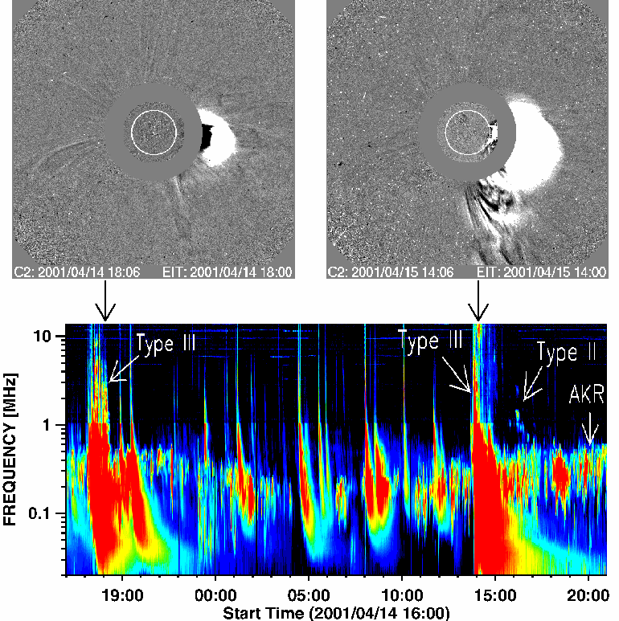
Fig. 2. SOHO/LASCO running-difference images CME1 and CME2 from AR 9415: at 18:06 UT on 2001 April 14 (top left) and 14:06 UT on 2001 April 15 (top right). SOHO/EIT (195 Å) difference images are superposed to indicate the solar sources. All difference images have the preceding frames subtracted. The white circle inside the occulting disk of the coronagraph is the optical Sun. The times of the LASCO images are marked on the Wind/WAVES dynamic spectrum (bottom). Both CMEs were associated with complex type III bursts, but only CME2 had a DH type II burst. Type III, type II and the auroral kilometric radiation (AKR) are marked.

Both CMEs were associated with coronal shocks as inferred from metric type II bursts (Tylka et al. 2002 have incorrectly stated that no type II emissions had been reported for SEP1), but only CME2 was associated with an IP type II burst (see Figure 2, bottom panel) observed by the Radio and Plasma Wave (WAVES) experiment (Bougeret et al., 1995) on board the Wind spacecraft. Intense complex type III radio bursts occurred for an hour in association with both CMEs. Type II-like features were embedded among the type III bursts starting at about 14:00 UT for CME2, but no such features were found for CME1. There were also two episodes of fundamental harmonic pairs of decameter-hectometric (DH) type II bursts at 15:48 and 16:06 UT. The second episode was relatively strong and continued to lower frequencies (down to 600 kHz around 17:00 UT) where it was completely masked by the auroral kilometric radiation (AKR, see Figure 2). There were also weak occasional brightenings down to 40 kHz (not shown). An IP shock was detected in situ on 2001 April 18 at 00:50 UT by Wind and at 14:30 UT by Ulysses (located at S23.5W128 closer to the nose of CME2 at a heliocentric distance of 1.41 AU). The transit time was 59.5 hrs to Wind near 1 AU and 73 hrs to Ulysses. Although there were many shocks (detected in situ and inferred from radio observations) that originated from AR9415, there was no shock at 1 AU after 2001 April 14 at 01:40 UT until the shock in question, so we are confident that the shock came from CME2 (there was no shock at 1 AU or at Ulysses corresponding to CME1). The shock arrival was also marked by a sudden commencement, and a moderate geomagnetic storm (Dst = -101 nT) followed. The shock speed was only ~ 550 km/s, probably because we are looking at the eastern flank of the shock. An extended complex ejecta was observed for more than 40 hrs, starting at ~12:00 UT on 2001 April 18 (D. Berdichevsky, private communication). It is not clear if the ejecta has something to do with CME1 and CME2. There was a filament disappearance from S23W02 several hours after CME1, which is a possible source for the ejecta. Thus, the interpretation of the 1-AU ejecta is not clear, and needs further work.

Table 1. Comparison between the 2001 April 14 and 15 SEP Events

 | April 14, 2001 (CME1) | April 15, 2001 (CME2)
p (>10 MeV) intensity | <2 pfu | 1000 pfu
CME onset in C2 FOV | 17:54 UT | 14:06 UT
CME onset at 1R_{s} | 17:29 UT | 13:32 UT
CME position angle | 263 deg | 245 deg
CME speed | 830 km/s | 1200 km/s
CME width | 113 | 167
H-alpha flare size | SF | 2B
Flare onset | 17:15 UT | 13:19 UT
Flare rise time/duration | 54 min/73 min | 31 min/137 min
X-ray flare size | M1.0 | X14.4
Source location, AR | S17W71, 9415 | S20W85, 9415
Microwave peak | 15.4 GHz? | 15.4 GHz
Metric type II | 17:50-17:58 UT | 13:48-13:55 UT
Metric type II frequency | 44-25 MHz | 80-30 MHz
WAVES type II | ? | 14:00 UT
Complex type III | 17:15-18:15 UT | 13:40-14:54 UT
Preceding wide CME from the same AR? | No | Yes
Shock at 1 AU | None | 00:50 UT 04/18
Ejecta at 1 AU | ? | 12:00 UT 04/18

COMPARITIVE ANALYSIS OF SEP1 AND SEP2

The difference between SEP1 and SEP2 may be due to : (i) Flare size, (ii) CME speed, and (iii) Coronal and IP environment. Flare size quantified as intensity in soft X-rays (Ix, in units of Watts/m²) has a good correlation with >10 MeV proton intensity (Ip, in units of pfu): log (Ip) = 4.86 + 0.63 log (Ix). This relation was obtained using major (Ip > 10 pfu) SEP events of cycle 23 (Gopalswamy et al., 2003). According to this relation, the M1.0 flare should result in an Ip of 50 pfu, while the X14.4 flare should be associated with an Ip of 1.2 x 10³ pfu. The observed Ip is quite close to the statistical value for the X-flare, but smaller by an order of magnitude for the M-flare. Gopalswamy et al. (2003) also obtained the following relation between Ip and CME speed (V, km/s) for western SEP events: log (Ip) = - 9.08 + 3.7 log (V), according to which, CME1 and CME2 should have yielded an Ip of 43 and 206 pfu, respectively. Thus the observed proton intensity of SEP1 is an order-of-magnitude smaller than what is expected from the empirical relationship of SEP intensity with flare-size and CME-speed. One might argue that the statistical relationship we used was derived from large SEP events, so it may not be applicable to SEP1, but the speed and width of CME1 are well within the range for large SEP events (see Kahler, 2001; Gopalswamy et al., 2003). On the other hand, the observed Ip for SEP2 is consistent with what is expected from the flare size, but not from the CME speed (the expected value is smaller than the observed by a factor of 5).
Now let us look at the ambient medium into which CME1 and CME2 were launched. AR 9415 was active during its disk passage (April 3-17, 2001) producing many CMEs and flares. Three C-class flares, and a small eruption visible in EUV at 08:48 UT on April 14 preceded CME1 (see Solar Geophysical Data, April 13-14, 2001). There was a CME (position angle, PA = 264º, speed = 310 km/s) ahead of CME1 at 09:30 UT that faded out within C2 FOV (marked p1 in Figure 2). For CME2, there were two preceding C-class flares from AR 9415, apart from the M1.0 flare associated with CME1. There were also two wide CMEs (p2 and p3 in Figure 1) that preceded CME2. Movies of LASCO images revealed that a southwestern CME (PA=199º, speed = 511 km/s), which appeared in the LASCO field of view at 11:18 UT (April 15) was clearly pushed aside by CME2 around 14:30 UT. There was another wide CME above the west limb (PA = 330º, speed = 301 km/s) at 09:30 UT (April 15), which may be a composite with a part coming from AR 9415. More importantly, CME2 was preceded by CME1 by 20 hours. There was no such preceding CME ahead of CME1 for nearly 56 hrs: the nearest one was a large eruption on April 12 at 10:31 UT (halo CME with speed = 1184 km/s). Thus the coronal and IP environments of CME1 and CME2 seem to be quite different: the upstream medium of CME1 was cleaned out by the April 12 CME, while that of the CME2 has the closed filed lines of CME1 and the associated turbulence. These observations contradict the conclusion of Tylka et al. (2002) that the two CMEs were “launched into similar interplanetary conditions.”
How can we reconcile the present observations from the current paradigms for impulsive (flare) and gradual (shock) SEP events? The impulsive SEP1 was associated with fast and wide CME, similar to a typical gradual SEP event. It was also associated with a metric type II burst, indicative of CME-driven shock early in the event, yet the SEP intensity is an order of magnitude smaller than one would expect from a gradual event of this CME speed or flare size. Most of the observed protons seem to come from the associated flare, with almost no contribution from the CME-driven shock. This is also consistent with the fact that the metric type II burst died off when CME1 was around a height of 3 Rs (at 17:58 UT). It is possible that the coronal Alfven speed, which peaks around this height (see, e.g. Gopalswamy et al., 2001) might have been similar to the CME speed so the shock did not continue beyond this height. Interestingly, the flare also ended at 18:28 UT, not too long after the end of the metric type II burst. For SEP2, the > 10 MeV peak occurred at 19:00 UT, several hours after the end (15:35 UT) of the X14 flare. Type II radio burst occurred at all wavelengths, so the presence of shock is confirmed for SEP2. Thus, SEP2 is consistent with shock particles. But the associated flare was more impulsive with a rise time of 31 min compared to the 74 min for the M-flare, so flare particles are likely to be produced, but probably not detected because of poorer magnetic connection (W85 for the X-flare compared to W72 for the M-flare); some of these flare particles might also have been further accelerated by the shock of CME2. At the time of the 10 MeV peak, CME2 was at a distance of ~ 27.5 Rs, propagating through the aftermath of CME1. The presence of CME1 ahead of CME2 has the following implications: (1) the M-flare and the coronal shock driven by CME1 are likely to contribute to the seed population to the shock of CME2, and (2) Shock acceleration is boosted because of its passage through the turbulent aftermath of CME1. SEP2 is one of the high-intensity (Ip > 50 pfu) events among a set of 16 in cycle 23 that were preceded by wide CMEs (width > 60º) within one day (Gopalswamy et al., 2003).

Coronal and IP Environment Ahead of CME2
CME2 and CME1 were traversing 6.2 and 4.3 Rs of the IP medium per hour, respectively (see Figure 1). When CME2 lifted off, CME1 was at a distance of ~ 85 Rs, assuming that the speed remained constant. CME2 approached CME1 at a rate of ~ 2 Rs per hour so it would overtake CME1 only after ~45 hrs (just before 1 AU). This rate may be different depending on how the two CMEs decelerated. What might be the nature of interaction between CME1 and CME2? Shock strengthening invoked for near-Sun interactions (Gopalswamy et al., 2001) may not apply in this case, which may also be the reason for not producing radio signatures of CME interaction. The ‘converging shock pair’ (Pomerantz and Duggal, 1974) scenario is also unlikely because there was neither an IP type II burst nor in situ shock associated with CME1. However, the system composed of CME2, its shock, and CME1 is capable of producing a high level of SEP intensity, in agreement with the simulation results of Kallenrode and Cliver (2001). Such a configuration is expected because the two CMEs originated from the same active region (AR 9415), so CME2 must be expanding in the space between the “legs” of CME1. The shock of CME2 might have propagated roughly parallel to the field lines of CME1, although the field lines are closed at a distance. Storage of the SEPs can occur in these closed field lines, which return the particles back to the shock of CME2 to be accelerated again, depending on the energy of the particles and the distance of the apex of the closed field lines. Enhanced turbulence in the disturbed IP medium ahead of the shock of CME2 is another source of scattering that can return particles for further acceleration (see, e.g., Bieber et al., 2002). Existence of open magnetic field lines needed for the escape of accelerated particles is evident from the extended type III bursts at DH wavelengths.

SUMMARY AND CONCLUSIONS

We analyzed two SEP events associated with fast and wide CMEs departing from AR 9415. Even though SEP1 was the largest impulsive event of cycle 23, it was associated with a large-scale fast CME (as in a gradual event). The traditional view that impulsive SEP events are not associated with CMEs has recently been revised to include narrow CME association (Kahler et al., 2001). Even this view has to be revised because SEP1 was associated with a fast and wide CME driving a coronal shock. SEP2 was a large gradual event consistent with the SEP flux-flare intensity relationship. However, it had much higher flux than expected from the SEP flux-CME speed relationship for gradual events. The eruption configuration itself was quite similar in both CMEs. Both had metric type II bursts, but only the second SEP event had an IP type II burst. The main differences between the two events were: (i) the CME speed (830 vs 1200 km/s), (ii) connectivity to Earth (W72 vs W84), (iii) associated flare size (M1.0 vs X14.4), (iv) association of IP type II burst (no vs yes) and (iv) the occurrence of preceding CMEs (no vs yes). We suggest that the occurrence of CME1 and the associated flare might have influenced the resulting intensity of SEP2 by providing seed particles and an environment conducive for efficient shock acceleration. The shock of CME2 and the closed field lines of CME1 form the ‘shock + Gold-Bottle’ configuration considered by Kallenrode and Cliver (2001) to explain the high intensity events known as ‘rogue events.’ It must be emphasized that the high-intensity SEP event presented here is not an isolated case: the majority of the high-intensity SEP events of cycle 23 have been found to have preceding wide CMEs within a day from the same source region (Gopalswamy et al., 2003).

ACKNOWLEDGMENTS

This work was supported by United States NASA (Living With a Star), Air Force Office of Scientific Research, and NSF/SHINE (ATM 0204588).

REFERENCES

Bieber, J. W., W. Droge, P. A. Evenson et al., Energetic Particle Observations during the 2000 July 14 Solar Event, Astrophys. J., 567, 622-634, 2002.
Bougeret, J.-L., M. L. Kaiser, P. J. Kellog et al., Waves: The Radio and Plasma Wave Investigation on the Wind Spacecraft, Space Sci. Rev., 71, 231-263, 1995.
Burlaga, L. F., K. W. Behannon, and L. W. Klein, Compound streams, magnetic clouds, and major geomagnetic storms, J. Geophys. Res., 92, 5725-5734, 1987.
Cliver, E. W., Solar flare gamma-ray emission and energetic particles in space, in High Energy Solar Physics, edited by R. Ramaty, N. Mandzhavidze, and X. M. Hua, pp 45-60, AI, Woodbery, NY, 1996.
Gopalswamy, N., S. Yashiro, M. L. Kaiser, R. A. Howard, and J.-L. Bougeret, Radio Signatures of interacting coronal mass ejections: Coronal mass ejection cannibalism? Astrophys. J., 548, L91-L94, 2001.
Gopalswamy, N., S. Yashiro, M. L. Kaiser, R. A. Howard, and J.-L. Bougeret, Interplanetary radio emission due to interaction between two coronal mass ejections, Geophys. Res. Lett., 29(8), 106: 1-4, 2002a.
Gopalswamy, N., S. Yashiro, G. Michalek et al., Interacting coronal mass ejections and solar energetic particles, Astrophys. J., 572, L103-L107, 2002b.
Gopalswamy, N., S. Yashiro, A. Lara et al., Large solar energetic particle events of cycle 23: a global view, Geophys. Res. Lett., 30(12), SEP 3:1-4, 2003.
Kahler, S. W., The correlation between solar energetic particle intensities and speeds of coronal mass ejections: Effects of ambient particle intensities and energy spectra, J. Geophys. Res., 106, 20947-20956, 2001.
Kahler, S. W., D. V. Reames, and N. R. Sheeley Jr., Coronal Mass Ejections Associated with Impulsive Solar Energetic particle Events, Astrophys. J., 562, 558-565, 2001.
Kallenrode, M.-B. and E. W. Cliver, Rogue SEP events: Modeling, Proc. of ICRC 2001, 3318-3321, 2001.
Levy, E. H., S. P Duggal, and M. A. Pomerantz, Adiabatic Fermi acceleration of energetic particles between converging interplanetary shock waves, J. Geophys. Res., 81, 51-59, 1976.
Lin, R. P., Solar particle acceleration and propagation, Rev. Geophys., 25, 676-684, 1987.
Mason, G., J. E. Mazur, and J. Dwyer, ³He enhancements in large solar energetic particle events, Astrophys. J., 525, L133-L136, 1999.
Odstrcil, D., M. Vandas, V. Pizzo, and P. MacNeice, Numerical simulation of interacting flux ropes, in Solar Wind 10, in press, 2003.
Pomerantz, M. A., and S. P. Duggal, Interplanetary acceleration of cosmic rays to relativistic energy, J. Geophys. Res.,79, 913-919, 1974.
Reames, D. V., Particle acceleration at the Sun and in the heliosphere, Space Sci. Rev., 90, 413-491, 1999.
Tylka, A. J., P. R. Boberg, C. M. S. Cohen et al., Flare- and Shock-accelerated Energetic Particles in the Solar Events of 2001 April 14 and 15, Astrophys. J., 581, L119-L123, 2002.
Torsti, J., E. Valtonen, M. Lumme et al., Energetic Particle Experiment ERNE, Solar Phys., 162, 505-531, 1995.
Vandas, M., S. Fischer, M. Dryer et al., MHD simulation of an interaction of a shock wave with a magnetic cloud, J. Geophys. Res.,120, 22295-22300, 1997.

E-mail address of N. Gopalswamy gopals@fugee.gsfc.nasa.gov
Manuscript received 13 December 2002; revised 13 August 2003; accepted 12 September 2003

